South Lake Elementary School PTO

*Date |time*  Monday 03.24..25 6:00 pm, South Lake Media Center  
*Meeting called to order by* Amanda Tullis at 6:07 pm  
*Attendance* taken via Google Form and duly recorded

# Officer Reports

**Treasurer’s Report**

CCU checking balance - $39,500.32

CCU savings balance - $2,004.92  
Accrued interest of $1.54 in February

February Finalized Budget

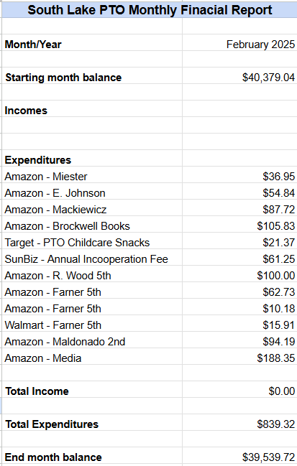

March Running Budget

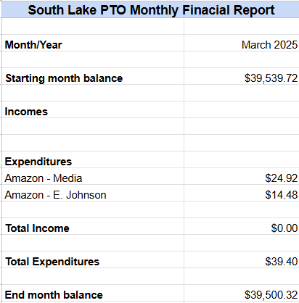

**President’s Report**

Amanda Tullis

Elections for 2025-26 PTO Board will be held at the PTO meeting on April 14, 2025. Officer interest forms will be emailed to all South Lake families through Focus by admin. It is a self-nomination process, so check your Focus messages if you are interested in any of the positions that are listed below.

Section 2. Nominations and Elections. Those interested in holding an officer position will self-nominate when the executive board or administration call for nominations. Once the self-nomination period has ended, the administration will compile a ballot to be presented and voted on at the second to last PTO meeting of the school year. Election results will be announced at the second to last meeting of the school year.  
  
Section 3. Eligibility. PTO participants are eligible for office if they are participants in good standing at least 14 calendar days before nominations are due. To be considered in good standing, participants must have completed and reported at least 10 service hours with South Lake Elementary School by the end of the first semester.  
  
Section 4. Terms of Office. Officers are elected for a one year term. Each person elected shall hold only one office at a time.

**Article IV – Officers and Elections**  
Section 1. Officers. The officers shall be a president, vice president, secretary, treasurer, vice president of fundraising, vice president of hospitality, and vice president of events.  
  
a. President. The president shall preside over meetings of the organization and executive board, serve as the primary contact for the principal, represent the organization at meetings outside the organization, serve as an ex-officio member of all committees except the nominating committee, oversee the officer elections process and committee chair recruitment, and coordinate the work of all the officers and committees so that the purpose of the organization is served.  
  
b. Vice President. The vice president shall assist the president and carry out the president’s duties in his or her absence or inability to serve. The vice president shall oversee committees and committee chairs.  
  
c. Secretary. The secretary shall keep all records of the organization, take and record minutes, prepare the agenda, handle correspondence, and send notices of meetings to the membership. The secretary also keeps a copy of the minutes book, bylaws, rules, membership list, and any other necessary supplies, and brings them to meetings.  
  
d. Treasurer. The treasurer shall receive all funds of the organization, keep an accurate record of receipts and expenditures, and pay out funds in accordance with the approval of the executive board. He or she will present a financial statement at every meeting and at other times of the year when requested by the executive board and make a full report at the end of the year.

e. Vice President of Fundraising. The vice president of fundraising shall plan and execute all PTO fundraisers, and oversee the fundraising committee.

f. Vice President of Hospitality. The vice president of hospitality shall plan and execute all staff appreciation events, shall solicit donations and items from vendors, businesses, and/or school families for all hospitality events, and oversee the hospitality committee.

g. Vice President of Events. The vice president of events shall plan and execute any special events for students, families, and the greater school community (such as family movie night, student recognition events, etc.), and oversee the events committee.

# Committee Reports

**VP Events**   
Alicia Hiett

Family trivia night will be next Friday, April 4th in the South Lake Cafeteria. Doors open at 5:30 pm and trivia will be from 6:00-7:00 pm. Cash concessions will be available (drinks, chips, candy). There will be 4 categories, 10 questions per category and a bonus question at the end. There will be a sign up genius to RSVP for the event.

Fintastic Friday is this Friday, March 28th. There is one volunteer spot open, so please see the Facebook page to sign up.

**Fundraising**   
Jessica Pittman

FUN RUN will be held onWednesday, April 16th during class activity time. The kickoff is next Wednesday, April 2nd and the fundraising period ends on April 18th. If we meet our school wide fundraising goal, then on May 19th we will have 321 Bounce with bounce houses and obstacle courses during activity time. We will have different prizes throughout the week from PTO and also there may be prizes/awards through the classrooms as well. We will be looking for volunteers to help hand out prizes and to assist on the day of the event.

**Hospitality**

Dana Carraway

March - This Wednesday, March 26th Honeysuckle will be providing staff lunch. Earlier in March the staff was treated to popcorn and a soda bar.

Teacher and Staff Appreciation Week will be May 5th-May 9th. PTO is collecting gift cards for each staff member so we are looking for about 70 gift cards to be donated. See the flyer below for more information. There are also gifts and giveaways during that week, so Dana is looking for businesses that would be willing to donate. Examples of some donation items are gift certificates from restaurants, hair salons, spa services, fishing trips, paddleboard tours, gift baskets, etc. We will also need volunteers for lunch on Wednesday of that week to help cover the lunchroom to give the staff a break. There will be more information as it gets closer, but if you know of anyone that would like to donate, please contact Dana Carraway.



# Old Business

**None**

# New Business

**None**

# Next Meeting and Adjournment

Monday, April 14, 2025 at 6:00 pm

Meeting adjourned at 6:31pm.

Attendance Record:

| Ben Anderson |
| --- |
| Renee Cone |
| Jennifer Brockwell |
| Alicia Hiett |
| Victoria Ausanka |
| Sheila Tischler |
| Dana Carraway |
| Alaina Lanoue |
| Jackie Sellers |
| Jennifer Reynolds |
| Laura Storey-Skelton |
| Geoffery McDole |
| Michelle Lang |
| Shari Brown |
| Courtney Shiffrin |
| Milannette Marin |
| Amanda Tullis |