South Lake Elementary School PTO

*Date |time*  Monday 02.10.25 6:00 pm, South Lake Media Center  
*Meeting called to order by* Amanda Tullis at 6:00 pm  
*Attendance* taken via Google Form and duly recorded

# Officer Reports

**Treasurer’s Report**

CCU checking balance - $40,093.70

CCU savings balance - $2,008.38  
Accrued interest of $1.70 in January

**January Finalized Budget**

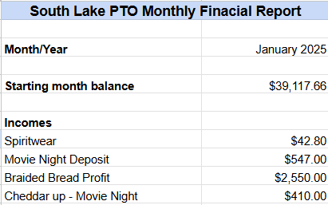

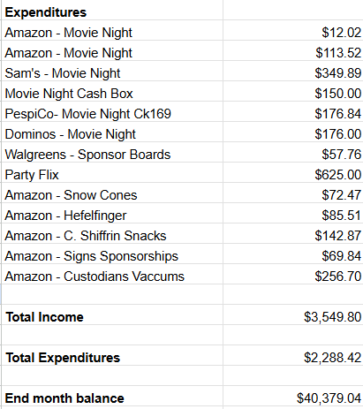

**February Running Financial Report**

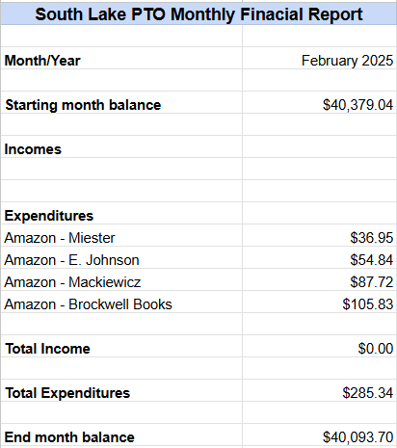

**President’s Report**

Amanda Tullis

The way that we log volunteer hours has changed. The Raptor system will no longer keep track of volunteer hours, but we will still need to sign in there while we are volunteering on campus.

All volunteer hours will need to be logged using the QR code that will be provided when you sign in and also at all PTO meetings. Volunteers are responsible for logging their hours on campus and off campus.

If you have any questions please contact the front office.

PTO is working hard to fund the Smart Lab next year. If you know of any businesses or someone in the technology or space industry that might be willing to donate, please let us know. We have a letter that can be given to potential sponsors. If you would like to have one to please email PTO at SouthlakePTO@gmail.com

PTO has given “Proud Supporter” yard signs to our business sponsors. They can be displayed in front of the business to show that they support South Lake.

# Committee Reports

**VP Events**   
Alicia Hiett

Family Trivia Night will be on April 4th. If you have experience with trivia and would like to volunteer please let us know. We will have 3 or 4 rounds with various subjects that will be able to be answered by various age groups.

**Hospitality**

Dana Carraway

February staff lunch will be themed “Soups and Sweets” for Valentine’s day. We are still in need of two more soups and there is a sign up genius on facebook. Two volunteers offered to make soups, so the list is now full.

March -There will be popcorn and a soda bar. Kate Toy won a giveaway and there will be a bag of popcorn for each staff member.

**Fundraising**   
Jessica Pittman

Fun Run will be Wednesday April 16th. This is a change from the original date in the blue calendar.

Fundraising will kick off on Wednesday, April 2nd. There will be different rewards for each fundraising level for the students. (Examples: music at lunch, throw water balloons at a teacher, etc).

There will also be extra challenges during the actual fun run to make it more exciting for the students. If they complete all of the challenges then they will receive an extra prize at the end.

If we meet the school wide fundraising goal, there will be a reward for all of the students. 321 Bounce is willing to loan us two large obstacle course inflatables and two large dry slides at flat cost. They will be set up during recess time for all of the classes to enjoy. 321 Bounce will not charge us extra fees for set up and delivery. Volunteers will be needed at all recesses to supervise inflatables. Mrs. Brockwell is getting details from BPS Risk Management to make sure that we are in compliance.

# Old Business

**None**

# New Business

Proposed: If we meet the school wide fun run fundraising goal, we will have an event with 321 Bounce; not to exceed $2,500.

Vote:

Motion-Victoria Ausanka

2nd-Alicia Hiett

Passed unanimously

# Next Meeting and Adjournment

Monday, March 24, 2025 at 6:00 pm

Meeting adjourned at 6:22 pm.

Attendance Record:

| Michelle Lang |
| --- |
| Heather Rohman |
| Alaina Lanoue |
| Courtney Shiffrin |
| Victoria Ausanka |
| Ben Anderson |
| Jennifer Reynolds |
| Michelle Moyers |
| Amanda Tullis |
| Jenica Will |
| Shari Brown |
| Alicia Hiett |
| Renee Cone |
| Anna Milam |
| Dana Carraway |
| Milannette Marin |
| Moriah Winfield |
| Sheila Tischler |
| Jessica Pittman |