South Lake Elementary School PTO

*Date |time*  Monday 01.13.25 6:00 pm, South Lake Media Center  
*Meeting called to order by* Amanda Tullis at 6:04 pm  
*Attendance* taken via Google Form and duly recorded

# Officer Reports

**Treasurer’s Report**

Current CCU Checking Balance - $38,671.43

Current CCU Savings Balance - $2,006.68

Accrued interest of $1.70 in November

Taxes have been submitted and accepted. It was a long process using the Tax Act program, so we would like to say a huge thank you to Moriah for taking care of it for us.

**November 2024**

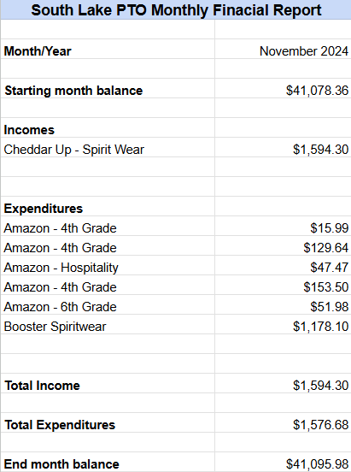

**December 2024**

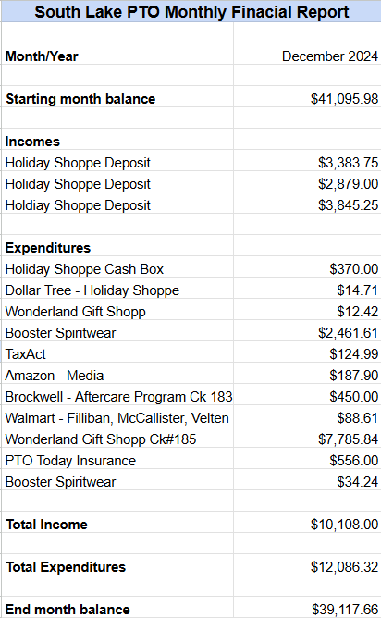

**Running Financial Report**

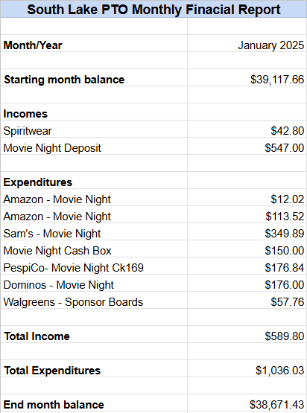

# Committee Reports

**VP Events**   
Alicia Hiett

Thank you to all of our Family Movie Night volunteers and attendees! We would like to say an extra thank you to Renee Cone, Laura Skelton, Terry Tullis, Michelle Gainer, Brandy Peterson, Lindsay Simmet, Nanci Chetta, Sheila Tischler, and Ryan Lewis for your help.

Up next: Family Trivia Night on April 4th, 6:00-7:30 pm.

**Hospitality**

Dana Carraway

Thank you, Honeysuckle and Dr. Goff’s office for feeding our faculty and staff!

Thank you to all of the families that donated during the holidays.

Fintastic Friday (snow cones) will be on January 31st.

**Fundraising**   
Jessica Pittman

Thank you to all of our Holiday Shop volunteers. We raised $1,925. We took in almost $11,000 in sales. We try to focus on the shop being a service for the students and their families, so we make a limited profit on this event.

FUN RUN will be held on February 7th. The kickoff is next Friday, January 24th!

This year will be a superhero theme. Ideas are needed for prizes, race challenges (and coordinator). We would like to have extra challenges with math problems, questions, etc. If anyone would like to help coordinate some grade appropriate questions please let PTO know.

A suggestion was made for room numbers and maps for the delivery of the prizes.

The question was asked about what the incentive may be for the students for meeting our goal. Amanda is looking into events/incentives and we will discuss more at the February meeting.   
Volunteers are needed for set up and day-of- event.

We are looking for anyone in the space or engineering industry to find a company to partner with to possibly sponsor the Smart Lab. If you know anyone, please contact PTO. Next year the Accelerated Reader Program also needs to be funded by PTO.

Next year’s budget should be at $35,000 in order to fund everything that we need to cover. We need to raise about $30,000 for the fun run to cover our budget and to pay for the prizes, etc. We raised $31,000 last year with the Fun Run. With all of that conversation, we are setting the goal at $35,000 for this year’s Fun Run.

# Old Business

**None**

# New Business

**None**

# Next Meeting and Adjournment

Monday, February 10, 2025 at 6:00 pm

Meeting adjourned at 6:33 pm.

Attendance Record:

| Roderick Lanoue |
| --- |
| Heather Rohman |
| Alaina Lanoue |
| Laura Storey-Skelton |
| Geoffery McDole |
| Jennifer Reynolds |
| Latisha Rutledge |
| Deidra Whelan |
| Barbara Rutledge |
| Ryan Whelan |
| Jenica Will |
| Stefanie Fitzwilliam |
| Courtney Shiffrin |
| Shari Brown |
| Victoria Ausanka |
| David Marquardt |
| Amanda tullis |
| Alicia Hiett |
| Moriah Winfield |
| Ben Anderson |
| Michelle Lang |
| Dana Carraway |
| Kate Toy |